My Strengths Profile
(worksheet for autistic employees)

My strength   | How this strength could be applied in the workplace   | Specific tasks or activities in my workplace that use this strength  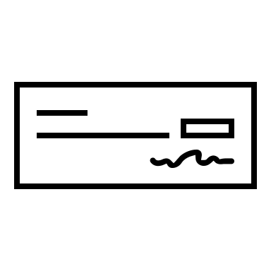

© Sandra Thom-Jones (2025)

